3.SOFTWARE PEER REVIEWS & INSPECTIONS

Module Name: Review & Inspection
Test Case ID: str_id_03
Webpage URL: https://swehb.nasa.gov/spaces/SWEHBVB/pages/32604573/SWE-087

- Scenario ID: 1a
Introduction & Purpose
This document presents a complete analysis of NASA SWE-087 (Software Peer Reviews and Inspections for Requirements, Plans, Design, Code, and Test Procedures) performed from the perspective of a Software Tester. All screenshots were captured from the official NASA Software Engineering Handbook page and are embedded below with explanations suitable for Tutorial-3 submission.
The goal is to understand formal requirement reviews, walkthroughs, peer reviews and inspections, their differences, roles, process steps, benefits and the critical value of performing them early (especially on requirements).

- Scenario ID: 2b
Main Requirement Statement
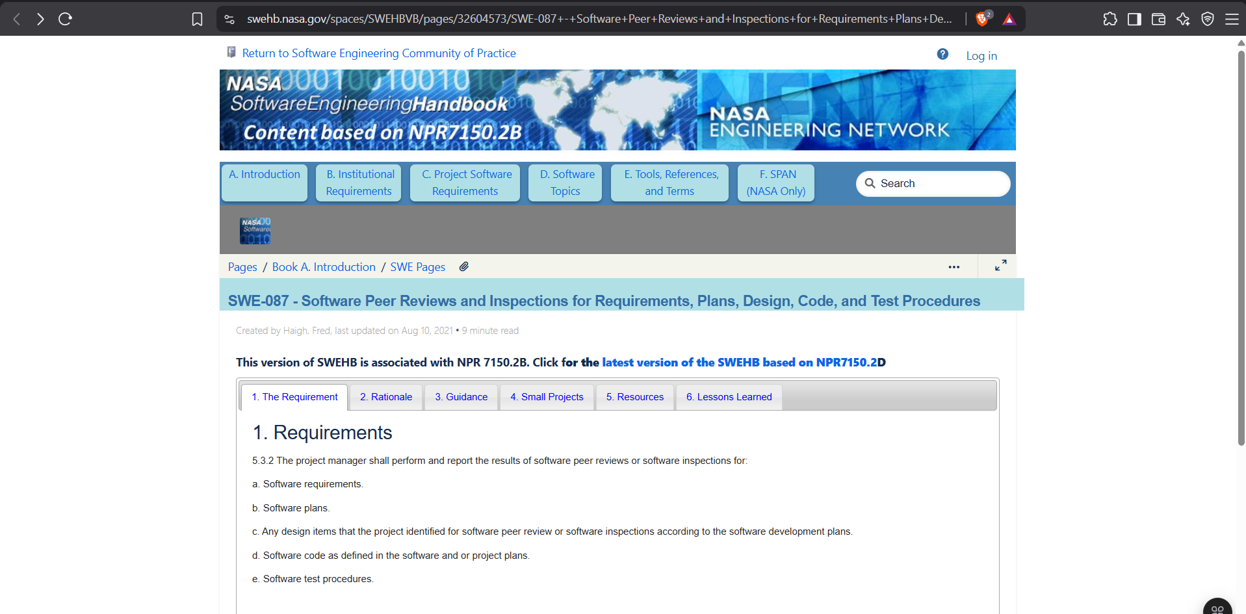

The core mandatory requirement (NPR 7150.2B §5.3.2) states that the project manager shall perform and report the results of software peer reviews or software inspections for:
- a. Software requirements
- b. Software plans
- c. Any design items identified for peer review/inspection according to the software development plans
- d. Software code as defined in the software and/or project plans
- e. Software test procedures
Tester Note: This is a ‘shall’ statement – mandatory. It covers the full set of artifacts most relevant to quality assurance and testing.

- Scenario ID: 3c
Notes & Best Practice Reference
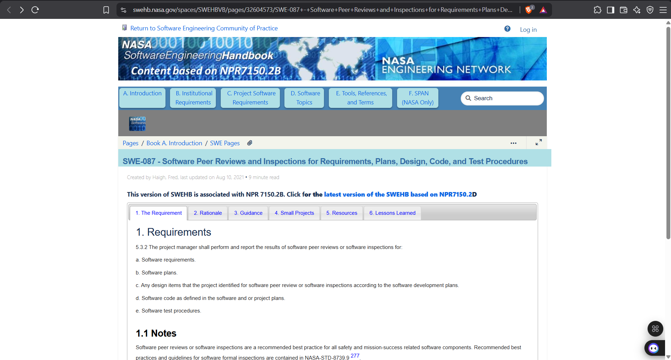

Software peer reviews/inspections are recommended for all safety and mission-success related software. Detailed guidelines are contained in NASA-STD-8739.9.

- Scenario ID: 4d
Benefits Table
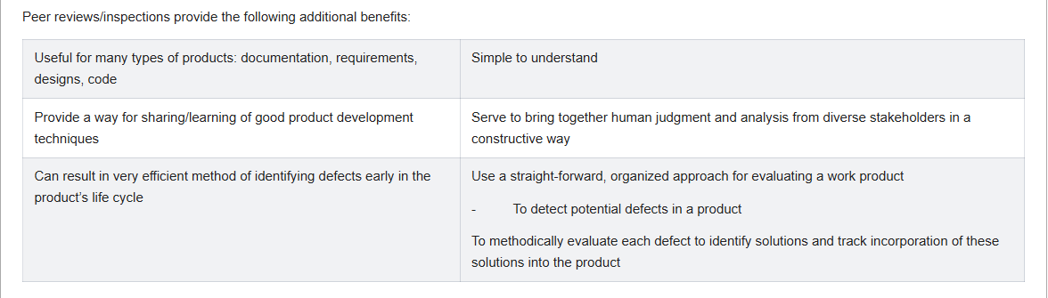

Key benefits extracted:
- Useful for documentation, requirements, designs, code
- Simple to understand
- Knowledge sharing of good development techniques
- Brings together diverse stakeholder judgment constructively
- Efficient early defect detection in the life cycle
- Organized approach to detect, evaluate and track defect solutions

- Scenario ID: 5e
Software Classification Matrix
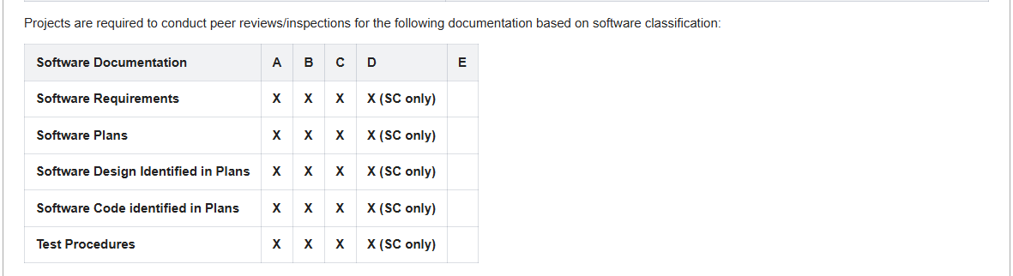

X marks indicate mandatory peer review/inspection. For Class D the requirement is limited to Safety-Critical (SC) items only. Class E has no mandatory entries shown. Academic projects can treat themselves as Class C and still apply the full set of reviews.

- Scenario ID: 6f
Roles Table
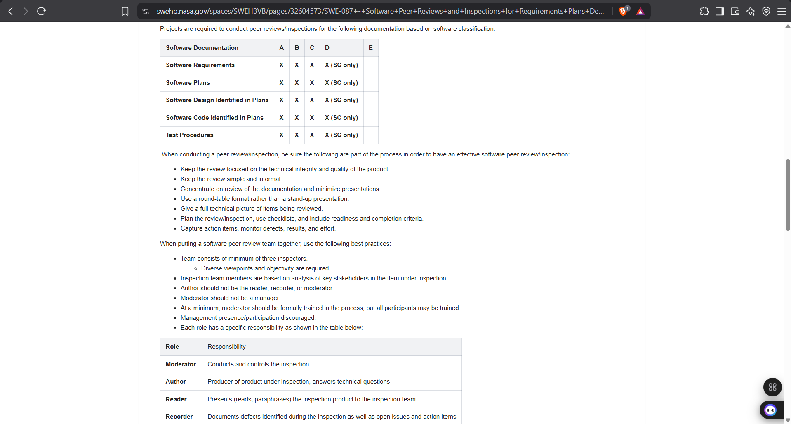

Defined roles:
- Moderator – Conducts and controls the inspection
- Author – Producer of the product; answers technical questions
- Reader – Presents (reads/paraphrases) the product to the team
- Recorder – Documents defects, open issues and action items
- Inspectors – Examine the product and identify defects (minimum 3)
Critical rule: Author must NOT be the Reader, Recorder or Moderator. Moderator should not be a manager.

- Scenario ID: 7g
Inspection Process Steps
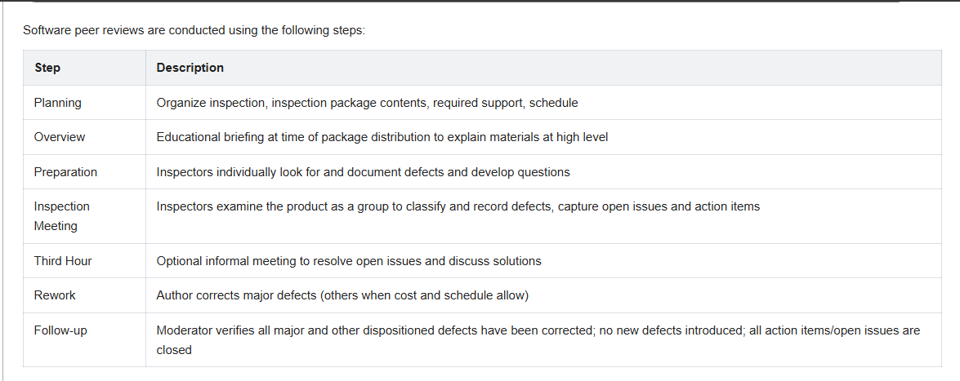

The formal process consists of:
- Planning – Organize package, support, schedule
- Overview – High-level educational briefing
- Preparation – Individual defect search & questions
- Inspection Meeting – Group classification & recording of defects
- Third Hour – Optional informal resolution of open issues
- Rework – Author corrects major defects
- Follow-up – Moderator verifies corrections & closure

- Scenario ID: 8h
Best Practices List
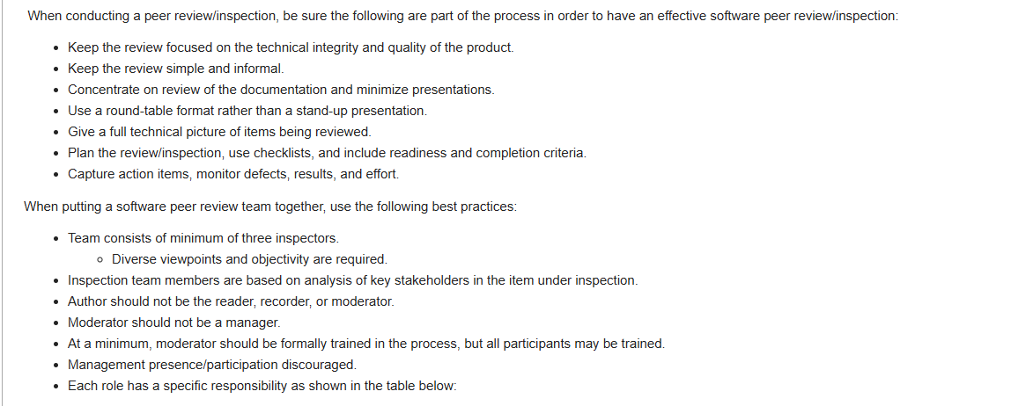

Process best practices include: keep focus on technical quality, keep simple/informal, minimize presentations, use round-table format, plan with checklists and readiness/completion criteria, capture action items and metrics.
Team best practices: minimum three inspectors with diverse viewpoints, stakeholder-based selection, Author excluded from Moderator/Reader/Recorder roles, Moderator trained and not a manager, management participation discouraged.

- Scenario ID: 9i
Rationale for Early Reviews
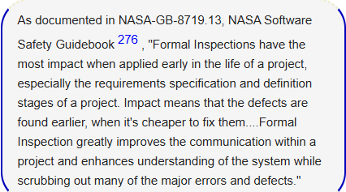

“Formal Inspections have the most impact when applied early in the life of a project, especially the requirements specification and definition stages of a project. Impact means that the defects are found earlier, when it’s cheaper to fix them…. Formal Inspection greatly improves the communication within a project and enhances understanding of the system while scrubbing out many of the major errors and defects.”
Tester Conclusion: This statement is the strongest justification for performing formal requirement reviews before design or coding begins. Defect cost multiplies dramatically the later it is found.

- Scenario ID: 10j
Walkthrough vs Formal Inspection – Comparison
Aspect | Walkthrough | Formal Inspection / Peer Review
Formality | Informal | Formal, process-driven
Leadership | Usually the author | Moderator (not the author)
Preparation | Light / optional | Mandatory individual preparation
Roles | Flexible | Defined (Moderator, Reader, Recorder, Inspectors)
Goal emphasis | Understanding + defects | Defect detection + process metrics
Checklist | Optional | Strongly recommended
Output | Notes / action items | Formal defect log + metrics

- Scenario ID: 7g
Summary of Findings (Software Tester View)
- NASA SWE-087 makes peer reviews/inspections mandatory for requirements, plans, design, code and test procedures (class-dependent).
- Five well-defined roles exist; Author is deliberately excluded from control roles to preserve objectivity.
- A rigorous 7-step process ensures preparation, focused defect detection, rework and verified follow-up.
- Early application (especially on requirements) yields the highest return by finding defects when they are cheapest to fix.
- Best practices emphasize technical focus, checklists, metrics, diverse inspectors and exclusion of management from the meeting.
- For Tutorial-3 the student should: (a) apply a requirements checklist to the project SRS, (b) simulate or perform a walkthrough and a formal inspection, (c) produce a defect log, and (d) reflect on the differences and value of early reviews.

